A Walk in the Treetops

Maybe it’s those nature documentaries featuring lemurs swinging through the rainforest, but more and more Americans are taking to the treetops. In woodlands across the country, thrill seekers are flocking to adventure installations—aerial rope courses, floating boardwalks, and suspension bridges that weave an exciting path through the leafy canopy. Tree-Mendous, a company that conceives, constructs, and sometimes manages these arboreal attractions, happens to be located near my summer cottage in Upstate New York. Intrigued, I researched their services.

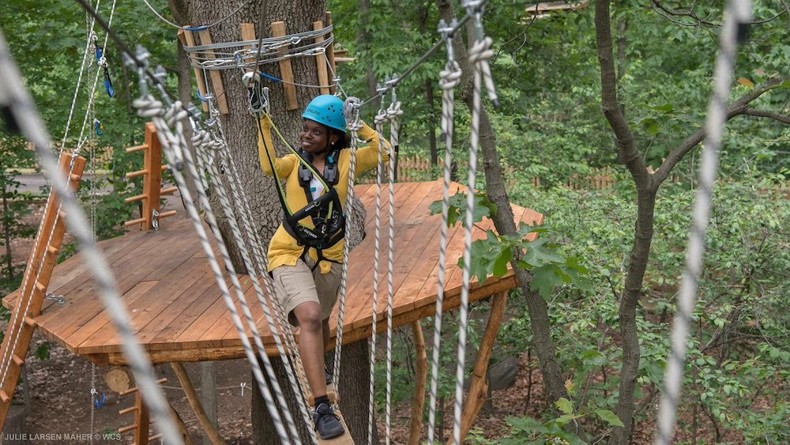

Bronx Zoo Treetop Adventure, New York City. Photograph by Julie Larsen Maher courtesy of WCS

As the company literature puts it, “Tree-Mendous designs and builds a unique variety of custom Aerial Attractions, Tree Top Adventure Trails, Tree Houses, Zip-Lines & Canopy Tours, Netted Attractions, Suspension Bridges, Nature Playgrounds, Climbing Walls, Jump Towers, Urban Installations, and much more.” It turns out they are responsible for a number of well-known attractions across the country, including the Bronx Zoo Treetop Adventure in New York City, the Ramblewild Aerial Adventure Park in Lanesborough, Massachusetts, and the West Mountain Aerial Adventure Park in Queensbury, New York.

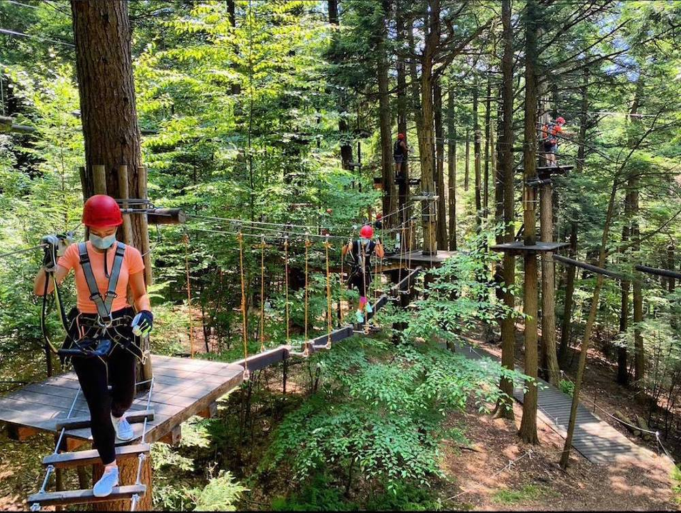

Ramblewild Aerial Adventure Park, Lanesborough, Massachusetts. Photograph courtesy of Ramblewild

To build its elaborate installations, the company avoids pressure-treated wood in favor of sustainably and locally harvested lumber selected from rot-resistant species. Black locust, a native hardwood that grows so abundantly throughout the U.S. it’s regarded as “invasive” in some regions, is a favorite. In fact, high-density black locust is the most rot-resistant wood we grow in our climate, making it an ideal material for fenceposts, outdoor furniture, decks, and other projects that require weatherproof materials.

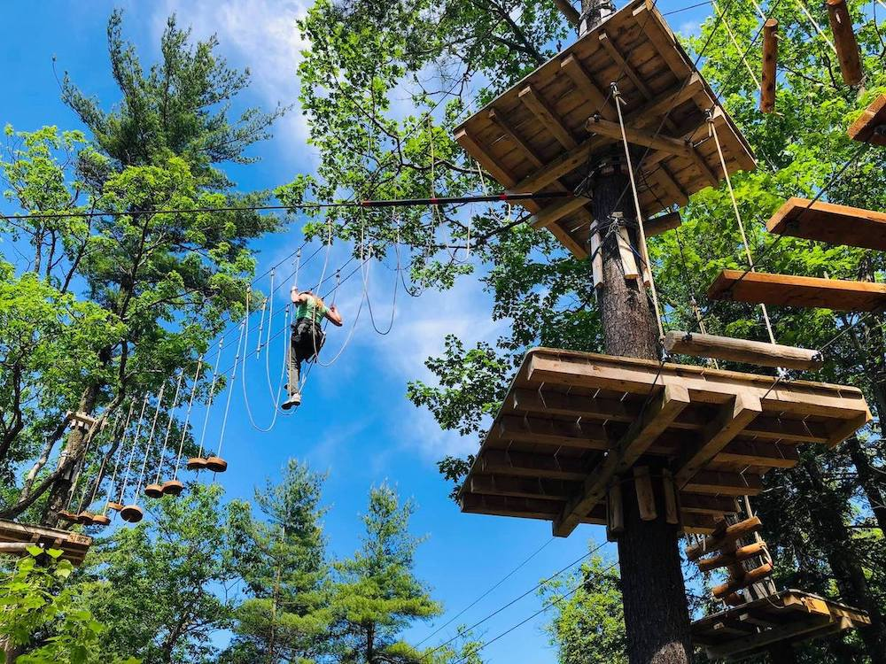

West Mountain Aerial Adventure Park, Queensbury, New York. Photograph courtesy of West Mountain Ski Area

Building an attraction involves more than just installing the treetop course. It includes the construction of facilities necessary for park operations such as ticketing, rental equipment, restrooms, and parking, all of which require excavation—something Tree-Mendous closely supervises since its goal is to leave the location as natural as possible. The company uses a proprietary system for suspending the various elements in the forest that is non-invasive and does not bolt or screw into the trees. In other words, it causes no more damage than lemurs do leaping happily from branch to branch.

Tree-Mendous Aerial Adventures
12913 State Route 22
Canaan, NY 12029
tree-mendous.com

Bronx Zoo Treetop Adventure
2300 Southern Boulevard
Bronx, NY 10460
bronxzootreetop.com

Ramblewild Aerial Adventure Park
110 Brodie Mountain Road
Lanesborough, MA 01237
newramble.com

West Mountain Aerial Adventure Park
59 West Mountain Road
Queensbury, NY 12804
westmountain.com/aerial-adventures

