3.21 Top Features and Design Trends for 2021

A recent survey conducted by the National Association of Home Builders (NAHB) identified “buyer preferences most likely to resonate in the 2021 market.” Identified as top features were laundry rooms, walk-in pantries, exterior lighting and customized outdoor spaces - patio and front porches - designed to not only provide more space, but to also create a seamless connection with the outdoors.

Other findings were that:

- “The average size home remained flat at 2,486 square feet, while the percentage of homes with four or more bedrooms and three or more bathrooms rose to 46 percent and 33 percent, respectively.

- An increased number of rooms within the same footprint means homeowners are becoming more creative in how they use the space within their homes, plus using features such as windows to help make these spaces feel larger.

- New homes are gaining popularity, with 60 percent of buyers preferring new homes—the highest level since 2007.

NAHB also asked recent and prospective home buyers how COVID-19 may have impacted their housing preferences. Sixty seven percent did not feel the pandemic had an impact. However, 25 percent did feel their preferences had changed because of COVID-19, with households that have at least one teleworker and one virtual student, being the most likely to feel an impact. Such households are also the most likely to desire a larger home.”

Visit www.nahb.org for more information.

https://www.nahb.org/news-and-economics/industry-news/press-releases/2021/02/NAHB-Identifies-Top-Features-and-Design-Trends-for-2021-in-the-Wake-of-COVID19

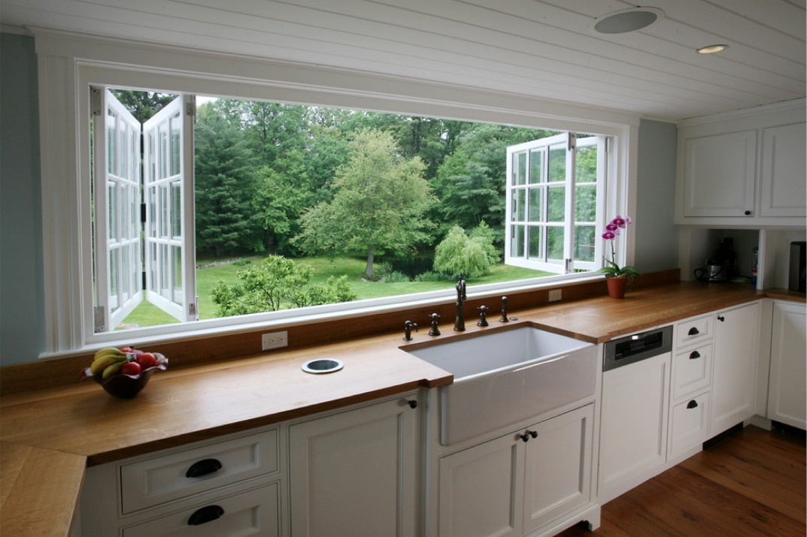

Archia Homes. Brooks Custom.

