American Oak, Texas Style

There are 90 species of oak native to the United States. Ever since the colonial era, we’ve been using the hardy, attractive, and plentiful hardwood for furniture, flooring, paneling, and building, making it familiar to every American; it’s even the country’s National Tree. Today’s architects, designers, and homeowners continue to find fresh, innovative ways to use oak in contemporary settings. Here’s a modern house that uses the venerable hardwood with 21st-century flair.

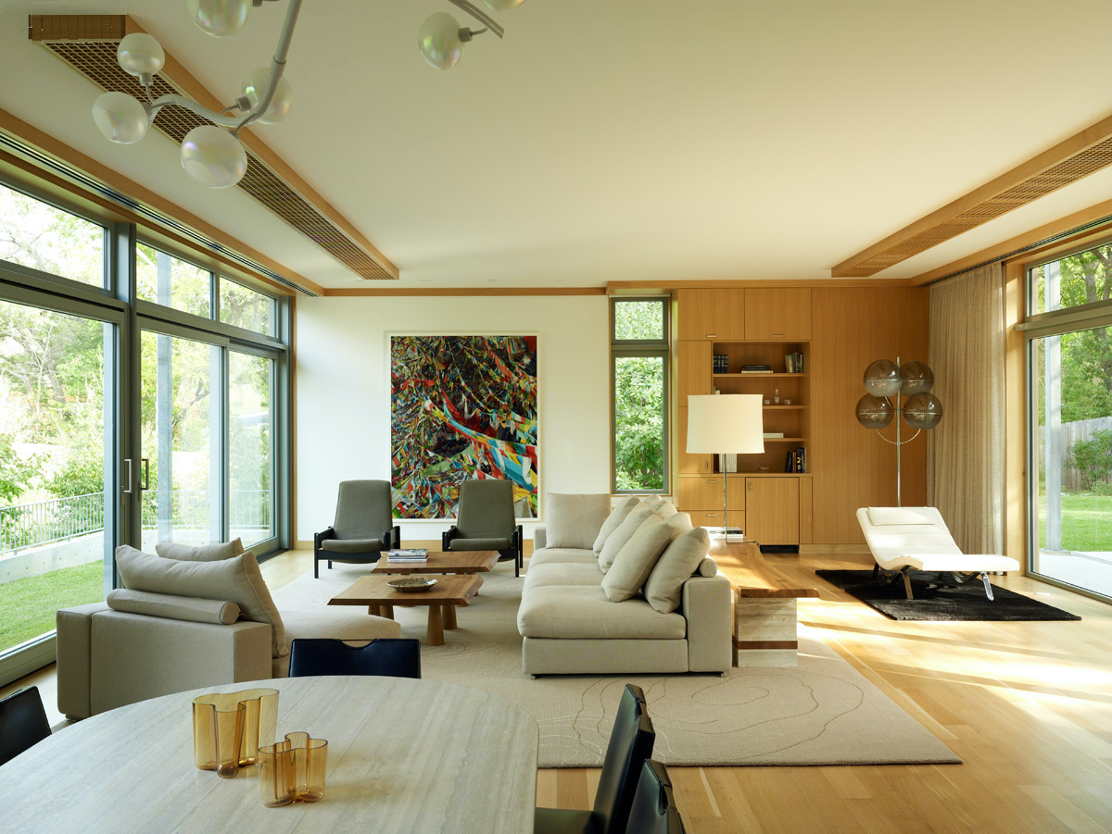

Floors are rift-sawn white oak in the living room of an Austin, Texas house by architect Ali Tayar. Photography by Joshua McHugh.

Among the late architect Ali Tayar’s last projects was a large house in Austin, Texas. Having previously designed the owner’s Manhattan loft, Tayar injected some Big-Apple sleekness into the sprawling residence’s laid-back, Lone-Star-State sensibility. Inspired by the oak-studded Texas landscape, Tayar specified rift-sawn white oak flooring throughout the house. He used the same wood for paneling, built-ins, staircases, trims and moldings, and kitchen cabinetry. This results in crisp, clean interiors united by their warm, honey-color floors and millwork.

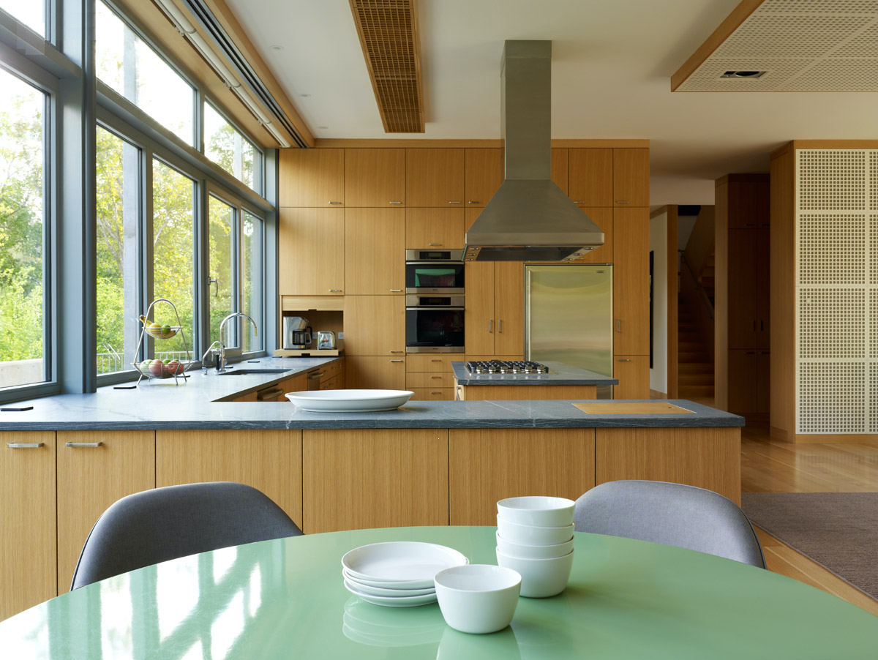

The kitchen’s white oak cabinetry was custom made by Arete Kitchens. Photography by Joshua McHugh.

With two walls made almost entirely of glass, the living room is especially light-filled. The expanse of blond wood underfoot glows in the Texas sunshine while a large slab of built-in cabinetry and shelving anchors one end of the room. Natural materials—wool rugs, cotton and leather upholstery, a stone-top dining table—add texture and subtle color. One unusual feature is the custom overhead lighting: long, flat, ceiling-hugging fixtures with gridded egg-crate diffusers made of—what else?—oak.

.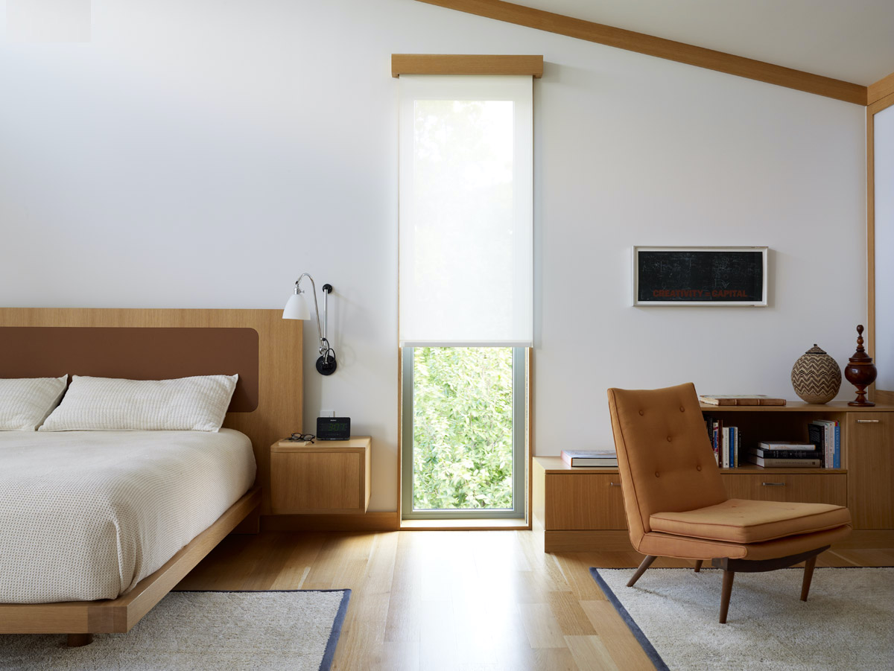

The master bedroom’s custom oak-and-leather headboard matches built-ins and trim work. Photography by Joshua McHugh.

The same light fixtures are used in the airy kitchen, where they complement the wall of custom cabinetry—a pared-down, floor-to-ceiling grid of tan wood juxtaposed with gleaming stainless-steel appliances and soft-gray marble countertops. And oak rules in the master bedroom, too, where it’s used not only for flooring but also for the custom wood-and-leather headboard, built-in cabinetry, and neat trim work, including natty wood valances that conceal the long shades whey they’re rolled up.

Arete European Kitchens
700 North Lamar Boulevard #100
Austin, TX 78703
aretekitchens.com

